Demonstrative Pronouns

🔹 What Are Demonstrative Pronouns?
# Source: AI Source: Provided by: [Data Path: Persons Table -> ID Column: 1, Name_En Column: Motasem Essam] -> From: [Chatgpt (GPT-4-turbo)] on [7/27/2025]
Demonstrative pronouns are pronouns that are used to point to specific people or things.
They show distance in space or time — either near or far, singular or plural.

✅ List of Demonstrative Pronouns
# Source: AI Source: Provided by: [Data Path: Persons Table -> ID Column: 1, Name_En Column: Motasem Essam] -> From: [Chatgpt (GPT-4-turbo)] on [7/27/2025]
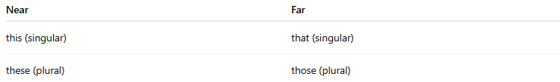
Near | Far
this (singular) | that (singular)
these (plural) | those (plural)

📚 Examples in Sentences
# Source: AI Source: Provided by: [Data Path: Persons Table -> ID Column: 1, Name_En Column: Motasem Essam] -> From: [Chatgpt (GPT-4-turbo)] on [7/27/2025]
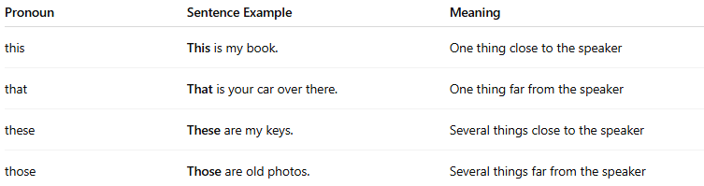
Pronoun | Sentence Example | Meaning
this | This is my book. | One thing close to the speaker
that | That is your car over there. | One thing far from the speaker
these | These are my keys. | Several things close to the speaker
those | Those are old photos. | Several things far from the speaker

⚠️ Don’t Confuse With Demonstrative Adjectives
# Source: AI Source: Provided by: [Data Path: Persons Table -> ID Column: 1, Name_En Column: Motasem Essam] -> From: [Chatgpt (GPT-4-turbo)] on [7/27/2025]
- Demonstrative Pronouns: stand alone
  - ✅ This is heavy.
- Demonstrative Adjectives: come before a noun
  - ✅ This box is heavy.

🔁 Summary
# Source: AI Source: Provided by: [Data Path: Persons Table -> ID Column: 1, Name_En Column: Motasem Essam] -> From: [Chatgpt (GPT-4-turbo)] on [7/27/2025]
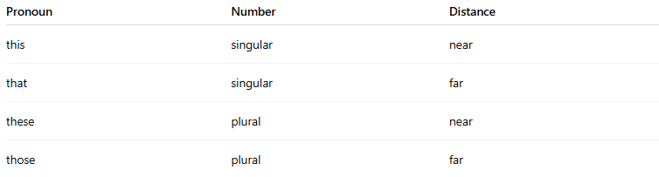
Pronoun | Number | Distance
this | singular | near
that | singular | far
these | plural | near
those | plural | far

